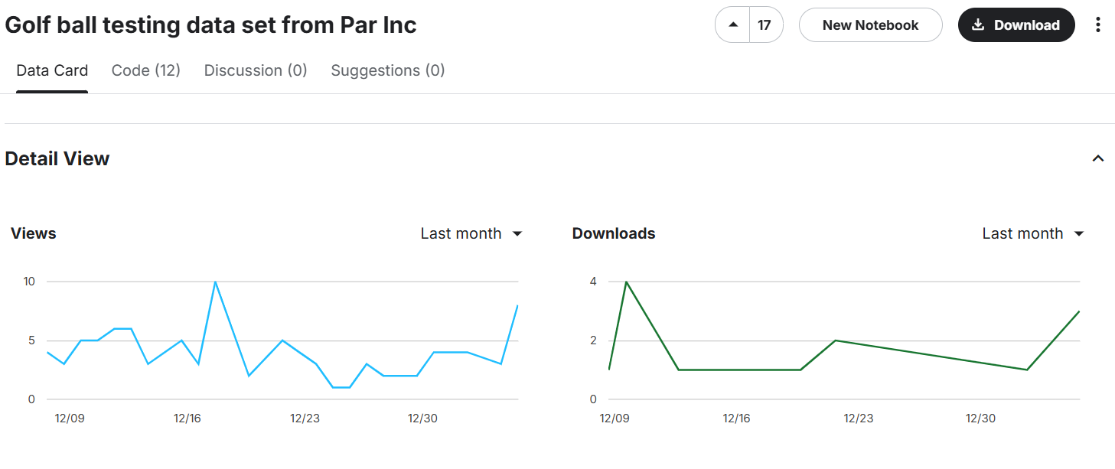About Dataset
Case Study: Par Inc
Par Inc., is a major manufacturer of golf equipment. Management believes that Par’s market share could be increased with the introduction of a cut-resistant, longer-lasting golf ball. Therefore, the research group at Par has been investigating a new golf ball coating designed to resist cuts and provide a more durable ball. The tests with the coating have been promising. One of the researchers voiced concern about the effect of the new coating on driving distances. Par would like the new cut-resistant ball to offer driving distances comparable to those of the current-model golf ball. To compare the driving distances for the two balls, 40 balls of both the new and current models were subjected to distance tests. The testing was performed with a mechanical hitting machine so that any difference between the mean distances for the two models could be attributed to a difference in the design.
GROUP MEMBERS
1.MUHAMMED NAJAF
2.ATHUL RAMAKRISHNAN
3.ALWIN JOSHY
4.NISHA P EAPPEN
5.MEGHANA MADHURI

